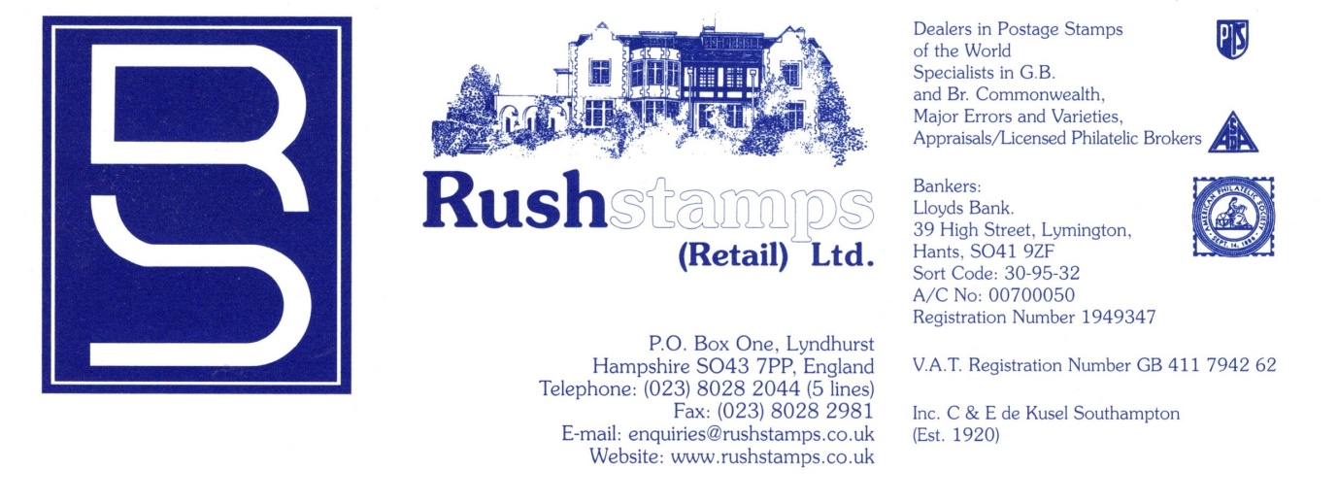
DECEMBER 2023
RUSHREPORT NO. 21

V.A.B. is back and here to stay! With the issuance of RushExpress Nos. 78 (Worldwide edition) and 79 (GB ‘Coronation’ Edition) we have decided to extend V.A.B. (Value Added Bonus) Vouchers which will be sent with your order automatically. It will equate to 5% of the value of the order supplied. So if you send us an order for £100 and we are able to supply all of it, you will receive a VAB Voucher for £5.00 and other amounts pro-rata which can be used against your next order within 21 days (28 days for Overseas).
Minimum Order Value £15 please.

CURRENT LISTS –Just Ask or View Online!
NEW WORLDWIDE RUSHTELEGRAPH NO. 73 – 64 pages of Great Britain, British
Commonwealth and Worldwide, including updated prices to RushExpress No. 79,
Lots & Collections, etc. (The Humdinger Edition!)
RUSHEXPRESS NO. 78 Worldwide Edition Comprising 112 pages of Worldwide A-Z including Errors & Varieties, Specimen Overprints, Etc. Too Good to Miss!
RUSHEXPRESS NO. 79 G.B.(CORONATION EDITION) 144 pages of G.B. 1840 to date – probably our best ever edition – fully revised and updated, 1000’s of lower prices and exciting discounts – too good to miss!

MANY PRICES HAVE NOW BEEN REDUCED, WELL WORTH A CLOSE LOOK!

IMPORTANT INFORMATION – WHEN PAYING BY CHEQUE PLEASE MAKE CERTAIN THAT IT IS PAYABLE TO RUSHSTAMPS (RETAIL) LTD.

SPRING SPECIAL OFFERS - G.B. POSTAGE
Save £40 ‘As it Comes’ values up to 50p (Face Value £100) – Commemoratives only
(Postpaid)…………………………………………………………………………………………………..…Now £60.00
100 x 1st Class Mixed Commemoratives, Face Value £125 only…………………………… £90.00
Do. per 1000………………………………………………………………………………………………………. £900.00
Quantities Pro-Rata

EXTRA SPECIAL OFFER
1993 £10 Britannia, SG 1658 Superb Unmounted Mint, Normally £14.95, New Price £13.50
‘Extra Special’ 3 for………………………………………………………………………………………………….. £40.00

PHILATELY “THE HOBBY OF KINGS”

MIXED LOTS –
FANTASTIC VALUE - £50, £100 & 250 LOTS – GREAT BRITAIN, BRITISH COMMONWEALTH, WORLDWIDE OR FOREIGN WITH ADDED 25% VALUE. CHOOSE QUANTITY OR QUALITY.

WE ACCEPT ANY MINT G.B. DECIMAL COMMEMORATIVE STAMPS AT 40% OF FACE VALUE AS A CREDIT AGAINT PURCHASES (20% for Pre-Decimal stamps)

CIGARETTE CARDS FOR SALE – Liquidating entire stock. Retail value over £28,000 was £6000 now just £2950 - Ask for list

G.B. 1990 SMILERS BOOKLET ERROR – Sealed Booklet showing Pane Inverted £50.00

WORLDWIDE
COMMERCIAL COVERS
1000’s accumulated inc. Airmail, Censors, a good and interesting selection
In £50, £100 & £250 Lots.
You can stipulate Quality or Quantity, also World- wide or Foreign only.

DISCOUNT G.B. POSTAGE – Mixed Values to 50p (Now Less 40%) £100 Bags………………….. £60.00

G.B. LIMITED EDITION (7,500 ONLY)
World War 1 Composite Sheetlet of 30 (A4 size) – Face Value £34.29!
Now only special offer (SG MS4138a, Cat. £65) £42.50, 3 for £125.00

WILDING BOOKLET
EXTRA SPECIAL OFFERS
N22p 2/- 1965 October (Cat. £12)…………. £ 4.50
L60p 4/6 1965 September (Cat. £32)………… £12.50
Q5p 6/- 1969 October (Cat. £90)……….. £30.00
X11 10/- 1965 December (Cat. £80)………. £30.00

1920’s Hyde Park Hotel
U/M…………………….. £1.50
Block of 4…………….. £5.00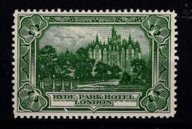

1948 SILVER WEDDING
£1 SG 493
U/M…………….. £9.95
F/U………………. £8.95
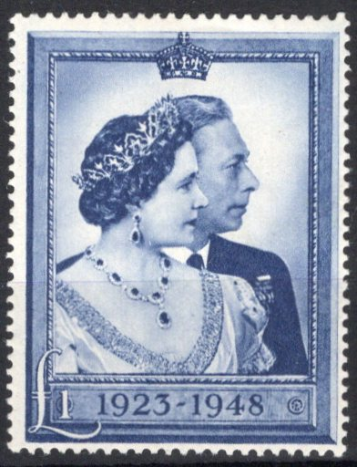

1953 CORONATION (4)
Fine Used……. £1.50

GERMAN WARTIME FORGERIES
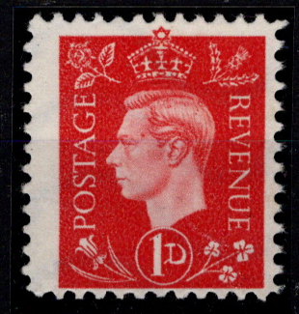
GEORGE VI ½d to 3d SPECIAL OFFER
VALUES) Unused or Cancelled….. £120.00
(Odd Values available £20.00 each)
1935 ½d Silver Jubilee inscribed ‘THIS
WAR IS A JEWISH WAR’ (Unused or
Cancelled)………. £85.00
1937 1½d Coronation inscribed ‘SSR
BRITANIA/TEHRAN’ (Unused or
Cancelled)………. £85.00

A MACHIN EXCLUSIVE – QUEEN’S 95TH BIRTHDAY UNIQUE PANE
Machin 1st Class NEW “M21L” and “MAIL” with wider vignette phosphor bands – F/U and with an upwards shift of the Phosphor Bands
As illustrated…
Out of Stock

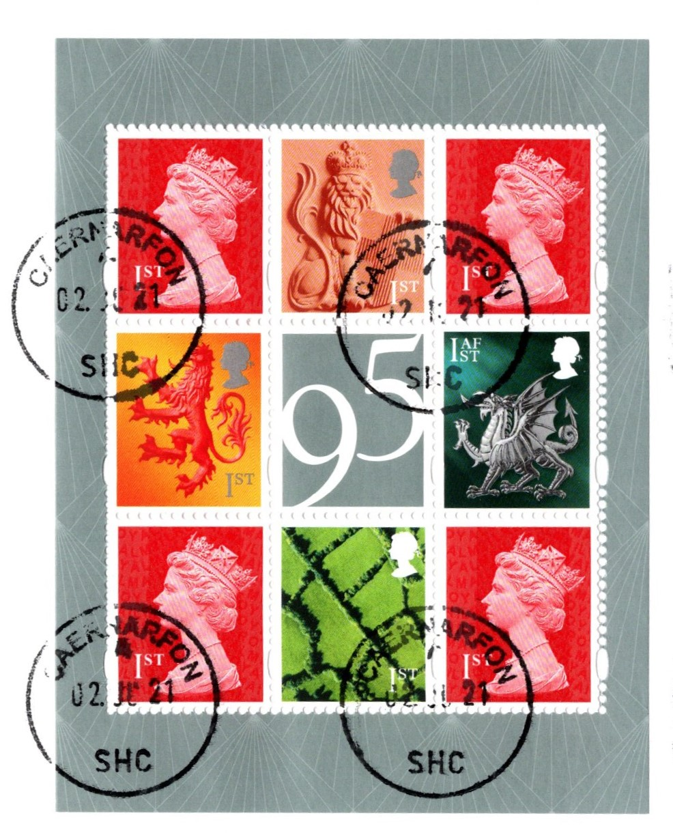

A few Mint copies available at £24.50

Get your Gift Vouchers for Birthdays
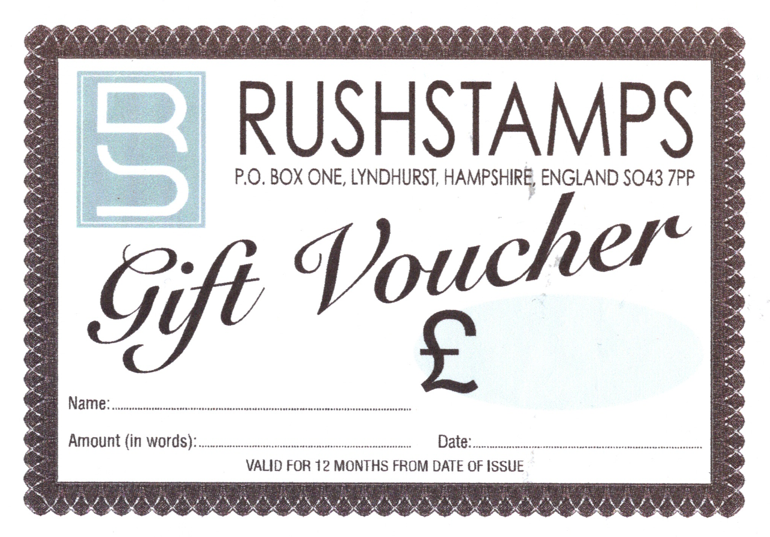
and Special Occasions now.

Available in any amount
(Minimum £25 please).

LATEST ARRIVALS LISTING

YOUR URGENT ATTENTION IS REQUESTED:
When placing orders over the telephone, please have your Customer Reference Number handy, this can be found on your Order Form. To save time, just give us your Name, Reference Number and Post Code and our Despatch Department will do the rest after your order has been processed! This will save both of us time. Thank you for your attention. HAPPY HUNTING! LOTS OF PRICE REDUCTIONS!

G.B. USED ABROAD – Ask for photocopies
G.B. MINT SURFACE PRINTED (All Conditions) – Ask for List/Photocopies
G.B. QUEEN VICTORIA USED INVERTED WMKS. – Ask for List/Photocopies
G.B. ERRORS & VARIETIES

COLLECTION OF AG BRADBURY COMMEMORATIVE STAMP CARDS – consisting of an A4 sized card with descriptive text and a Commemorative Stamp cancelled First Day of Issue (Cards, No. 10, 11, 24, 25, 26, 27, 28, 29, 30, 31, 32, 34 and 45) Most Cards Sold for £25 each, must be worth £125.00, Now only……………... £50.00 £35.00

G.B. DECIMAL MINT STAMPS – Commemoratives (inc. Miniature Sheets, Prestige Stamp Booklets and Smilers Sheets) can be unmounted or mounted. We credit you 40% of the current face value e.g. £10 face we credit you £4.00. Time to have a clear out!
No quantity is too large – (2nd NVI 75p, 1st NVI £1.25, “E” £2.20)

G.B. FDC’S – All with single value Commemoratives on plain or illustrated covers – can be anything, handwritten, charity covers, etc., etc., per 50 different……………………… £5.00

MYSTERY “WORLDWIDE OR FOREIGN ONLY COUNTRIES”
BUMPER MIXED LOTS – MASSIVE ACCUMULATION TO CLEAR!
Many many 1000’s of stamps – loose, in packets, on pages/stock cards, old Approval Books, etc.
A real Pot Pourri covering all periods – you will not be disappointed! Many days of sorting pleasure.
Help us find a good home! 25% ADDED VALUE NOW WITH EACH LOT
Lots of £100, £250 and £500 (all UK postpaid) – No two lots the same!

Something Different – Horizon Labels (now becoming popular).
We have accumulated a box full – as they come to include original white labels and gold series Perf. And Imperf used for various services, 100 ‘as they come’ NOW……£10.00

BRITAINS FIRST DECIMAL COIN SET
Issued in 1968 (½p, 1p, 2p, 5p & 10p) Uncirculated in special wallet, which contains the 5p and 10p coins minted and dated 1968, along with ½p, 1p and 2p coins pre-dated 1971, last few available……………………………………………………………………………. £4.50
OFFICIAL FOOTBALL ASSOCIATION COMMEMORATIVE COVERS
We are offering a Set of 4 historical F.A. Cup Final Covers with special Wembley cancellations:
1) 1994 Manchester United v. Chelsea showing Ryan Giggs, Sir Alex Ferguson, etc.
2) 1962 Tottenham v. Burnley
3) 1939 Portsmouth v. Wolverhampton Wanderers showing GVI presenting the Winner’s Cup
4) 1923 Bolton Wanderers v. West Ham
Only a limited number of these Covers were produced
These Covers generally sell between £3.95 and £5.95 each.
We can supply at £1.50 each, £5.00 for the set of 4

SHOWGARD MOUNTS – Due to supply issues we have decided to no longer stock these mounts and we will be running down the stock that we still have. We can offer an exceptional 10% discount on both Clear and Black Showgard mounts. Please send us your requirements now while stocks last. We will continue to stock Hawid mounts.

GREAT BRITAIN SPECIAL & ONE OFF OFFERS

EXTRA SPECIAL OFFER NOW
1902-13 Edward VII Definitive Shades/Varieties – Send for NEW listing with
Introductory 20% discount
1912 1d Scarlet-vermillion, SG 361 (Spec. N16(14)) in U/M corner marginal,
Cat. £160………………………………………………………………………… £95.00
1915 2s0d Booklet, SG BB7AVC – London EC Type I cancel March 1916,
Cat. £700, slight damage to front & back covers………………………………… £350.00
1929 P.U.C. (4v) FDC on plain cover with ‘High Wycombe’ CDS………………. £275.00
1931 5/- Booklet, SG BB34, Edition 6 (Cat. £3600)…………………………….. £1350.00
1934 5/- Booklet, SG BB35, Edition 7 (Cat. £1600)…………………………….. £650.00
1935 5/- Booklet, SG BB37, Edition 13 (Cat. £500)……………………………… £200.00
1937 Coronation in Vertical Pair Used with ‘Colon Flaw’,SG 461a(Cat. £70 as
mint)……………………………………………………………………………….. £20.00
1939 George VI 5/- on plain FDC addressed to the USA with ‘Menai Bridge’
CDS……………………………………………………………………………… £525.00
1940 5/- Booklet, SG BD25, Edition 9 (Cat. £1300)……………………..…….. £550.00
1942 5/- Booklet, SG BD26, Edition 4 (Cat. £1300)……………………………. £625.00
1948 Liberation 1d in Cylinder Block of 6 (Cyl. 2 No Dot) Perf. Type 6 I/P…… £5.00
1948 Liberation 2½d in Cylinder Block of 6 (Cyl.4 No Dot) Perf. Type 6B E/P
(Cat. £60)|………………………………………………………………………… £25.00
Do. Cyl. 4 No Dot, Perf. Type 6 I/P (Cat. £20)………………………………….. £12.00
Do. Cyl. 15 Dot, Perf. Type 5 E/I (Cat. £30)…………………………………… £20.00
1953 Coronation (4v) FDC on Art Craft cachet addressed to Canada with scarce
‘Windsor’ postmark…………………………………………………………….. £60.00
Do. small Registered envelope to London from Barclays Bank Limited cancelled
3rd June 1953 (First Day), must be worth………………………………………… £10.00
1969 6/- Jay Booklet ‘Gum Arabic’ SG QP47a, GGP normally £55.00………… £50.00
Do. QP47b, PGP normally £25.00……………………………………………….. £22.50
Do. QP47d, GPP normally £25.00……………………………………………….. £22.50
1971 Heinz Special Edition Presentation Pack which was issued October 13th to
promote their soup and lists their extensive range of flavours. For sending in eight
different soup labels you received this pack and the enclosed six 2½p stamps from
the Christmas issue, normally £19.50 now only…………………………………… £9.50
1972 Belgica Souvenir Pack……………………………………………………….. £2.00
2011 Machin Head Post & Go Labels SG FS1-5 (Type 1 from Wincor Machine)
plus FS5e (Type II from Wincor Machine)……………………………………… £25.00
2010-11 Birds 1-4 Post & Go Labels (Type II) in Sets of 6 x 1st Class up to 100g,
SG FS6,11, 16 & 21……………………………………………………………... £45.00
2012 Farm Animals 1-3 Post & Go Labels (Type II) in Sets of 6 x 1st Class up to
100g, SG FS27, 33 & 45…………………………………………………………. £22.50
2012 Christmas Robins Set of 6 (Type II) ‘MA13’ Date, SG FS51-56…………. £ 9.50
2011 £1.00 Machin DLR ‘MAIL’ (no source code) ‘M11L’, scarce…………… £19.50
2012 Olympics ‘All Purpose Essay’ in Uncut Sheetlet of 4 Miniature Sheets of 6
Showing no denomination, printed 19th June 2012 at Swindon, 1 only available £225.00
Do. Sheetlet of 6………………………………………………………………… £60.00
Do. single stamp…………………………………………………………………. £10.00
2012 Olympic (29v) in Sheetlets of 6 & Paralympic (34v) in Sheetlets of 2 on
Official First Day Covers - all stamps are from the ‘Coil’ printing and not from the
A4 Sheets which were supplied to Philatelic Counters and Post Offices and therefore
have NO PHOSPHOR. We are able to supply a few sets of the Olympics at…… £110.00
and Paralympics at………………………………………………………………… £95.00
2012 Christmas Robins Post & Go in Strips of 3 with ‘MA12’ Code……………. £15.00
Do. Strip of 6 with ‘MA13’ Code………………………………………………… £15.00
Do. Overprinted with ‘The B.P.M.A.’……………………………………………. £15.00
2015 Post & Go Machin Head, Poppy and Lion with ‘Sindelfingen’ (Germany)
Overprints on Strips of 4………………………………………………………….. £25.00
2015 Post & Go Machin Head, Flag, Poppy and Lion with ‘Paris’ (France)
Overprint on Strips of 4…………………………………………………………… £35.00
2016 Machin Head Se-tenant Strip of 6 with 87th Scottish Congress Opt. and “20g”
Omitted from Euro 20g Euro 10g dual value, scarce……………………………… £45.00
2018 Game of Thrones Post & Go ‘The Iron Throne’ se-tenant strip of 6, SG
FS201/06…………………………………………………………………………… £15.00
Do. with ‘The Postal Museum’ Overprint…………………………………………. £15.00
2022 Wales Barcoded 1st Class Regional with Different
‘Font’ Error and different Phosphor Bands printed in
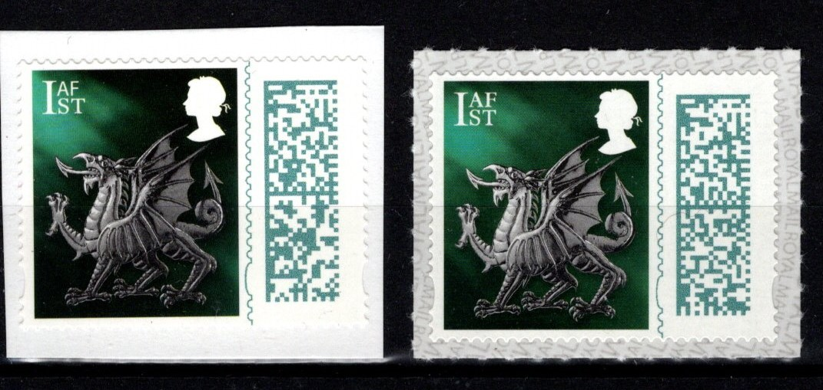
Special Coils for use only on Official FDC’s – unissued
in Mint condition! Few only available uncancelled on
piece with normal for comparison………………………. £10.00
2023 King Charles III 1st Class Barcoded Machin
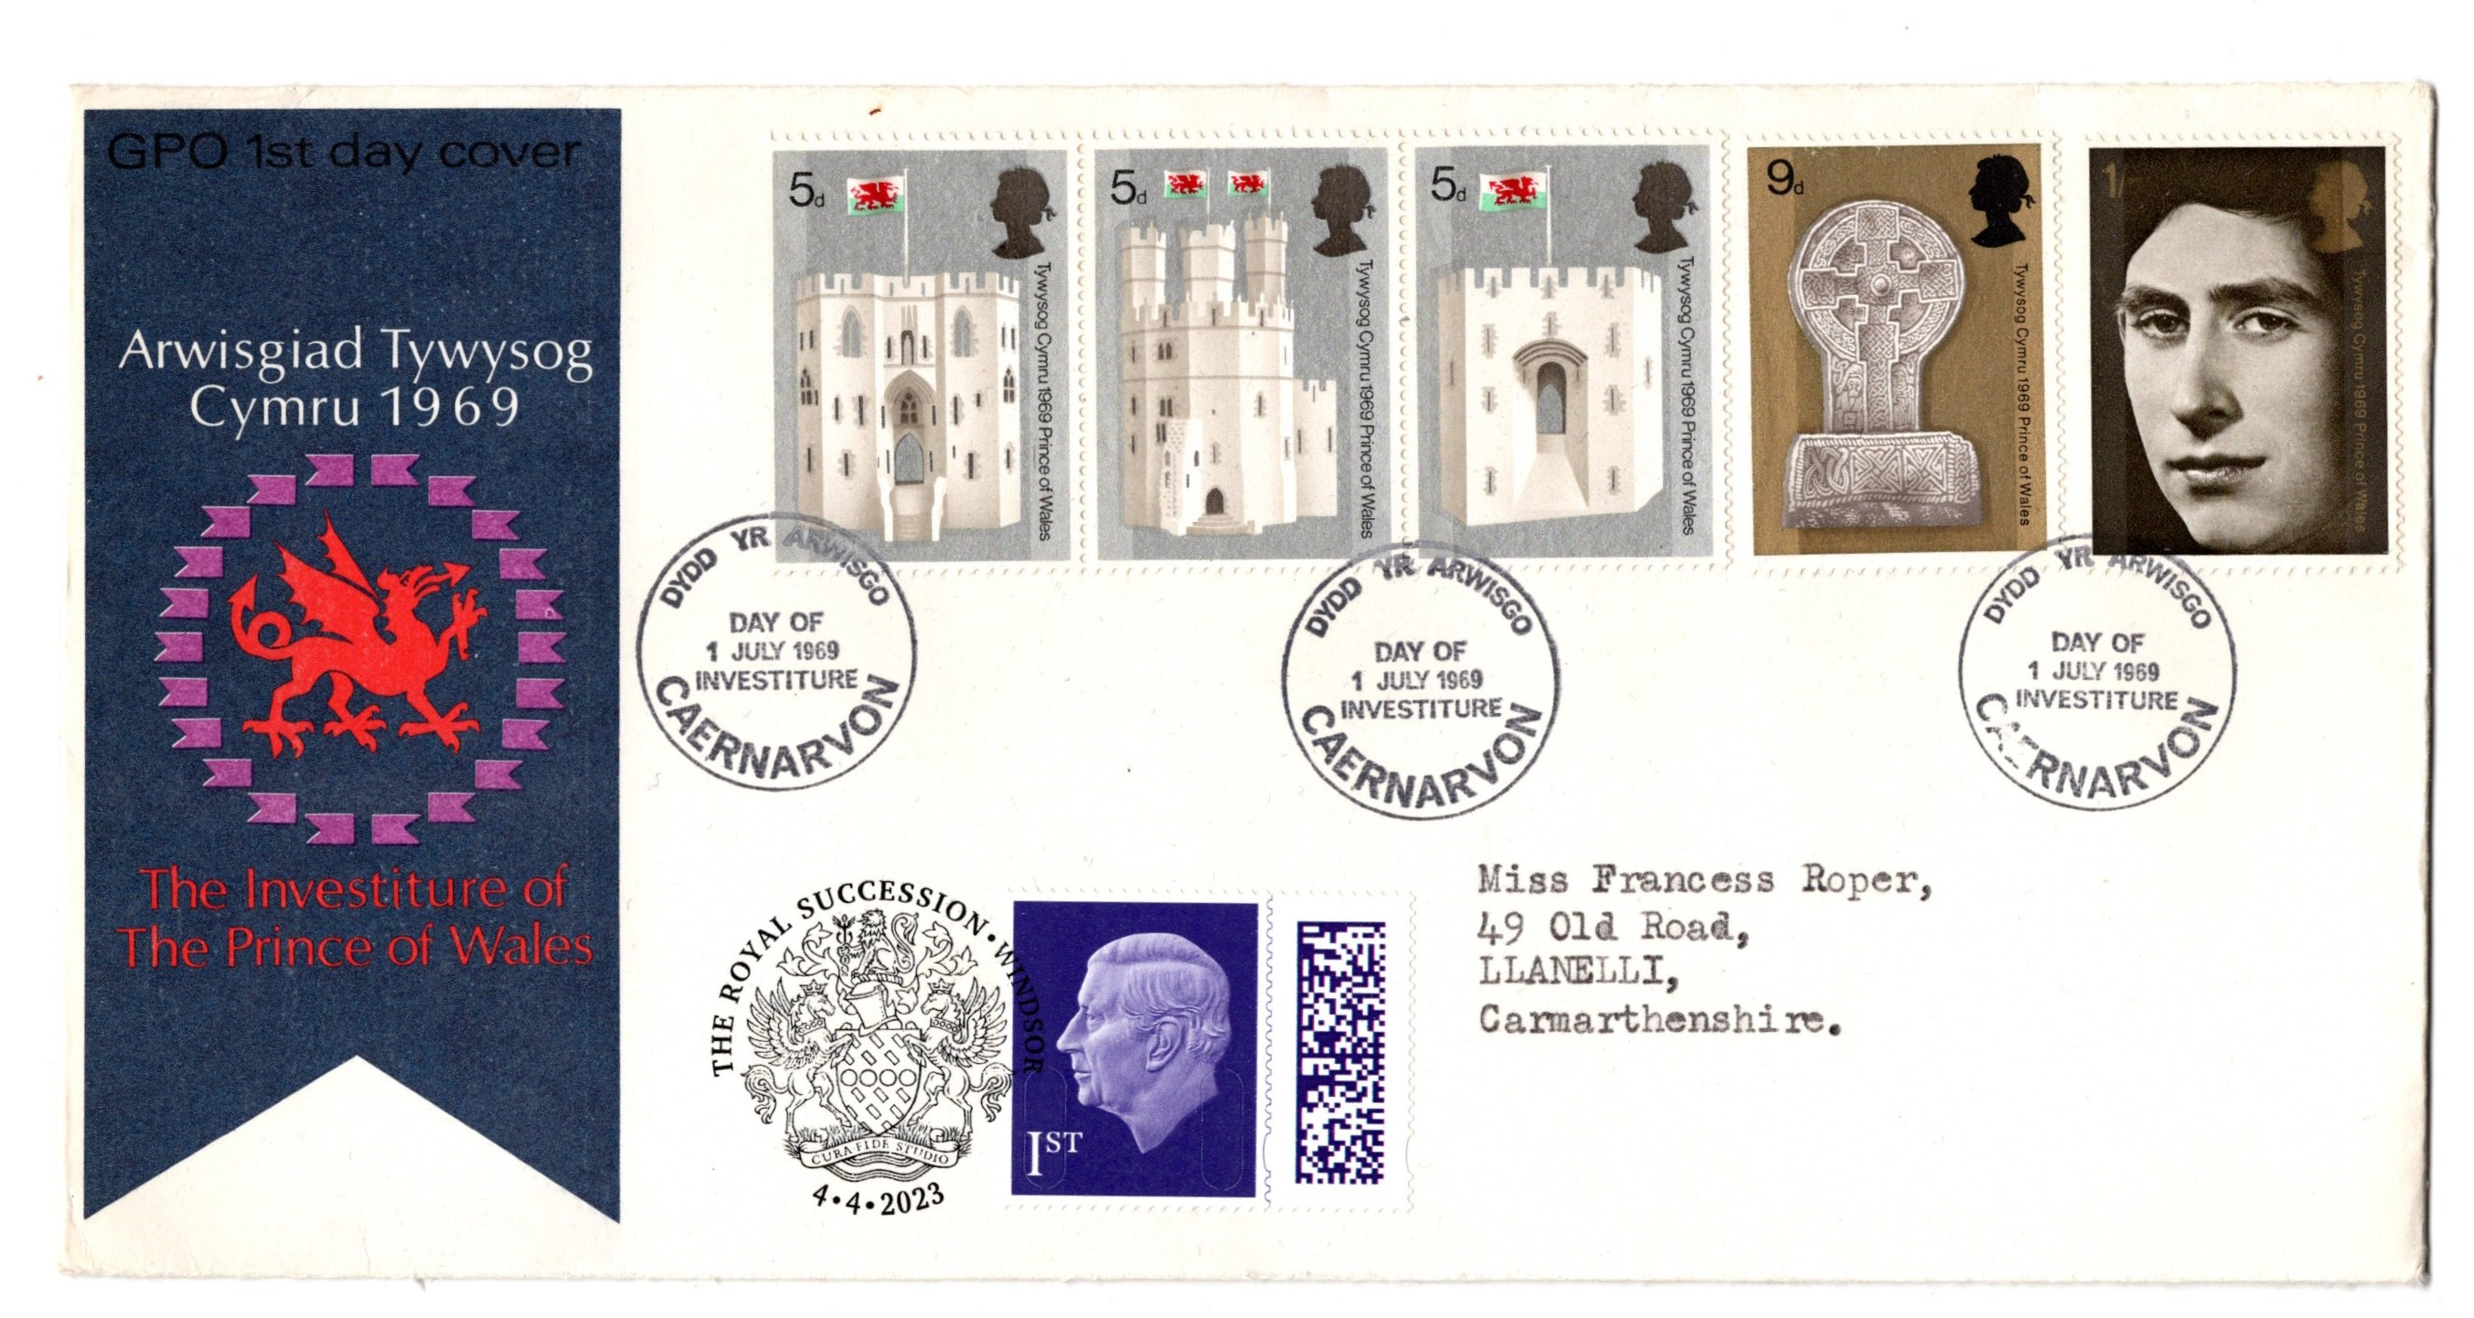
cancelled ‘The Royal Succession, Windsor’ on
Official Royal Mail 1969 Investiture (5v) FDC,
Only 100 produced………………… £ 5.00

2023 King Charles III Definitives
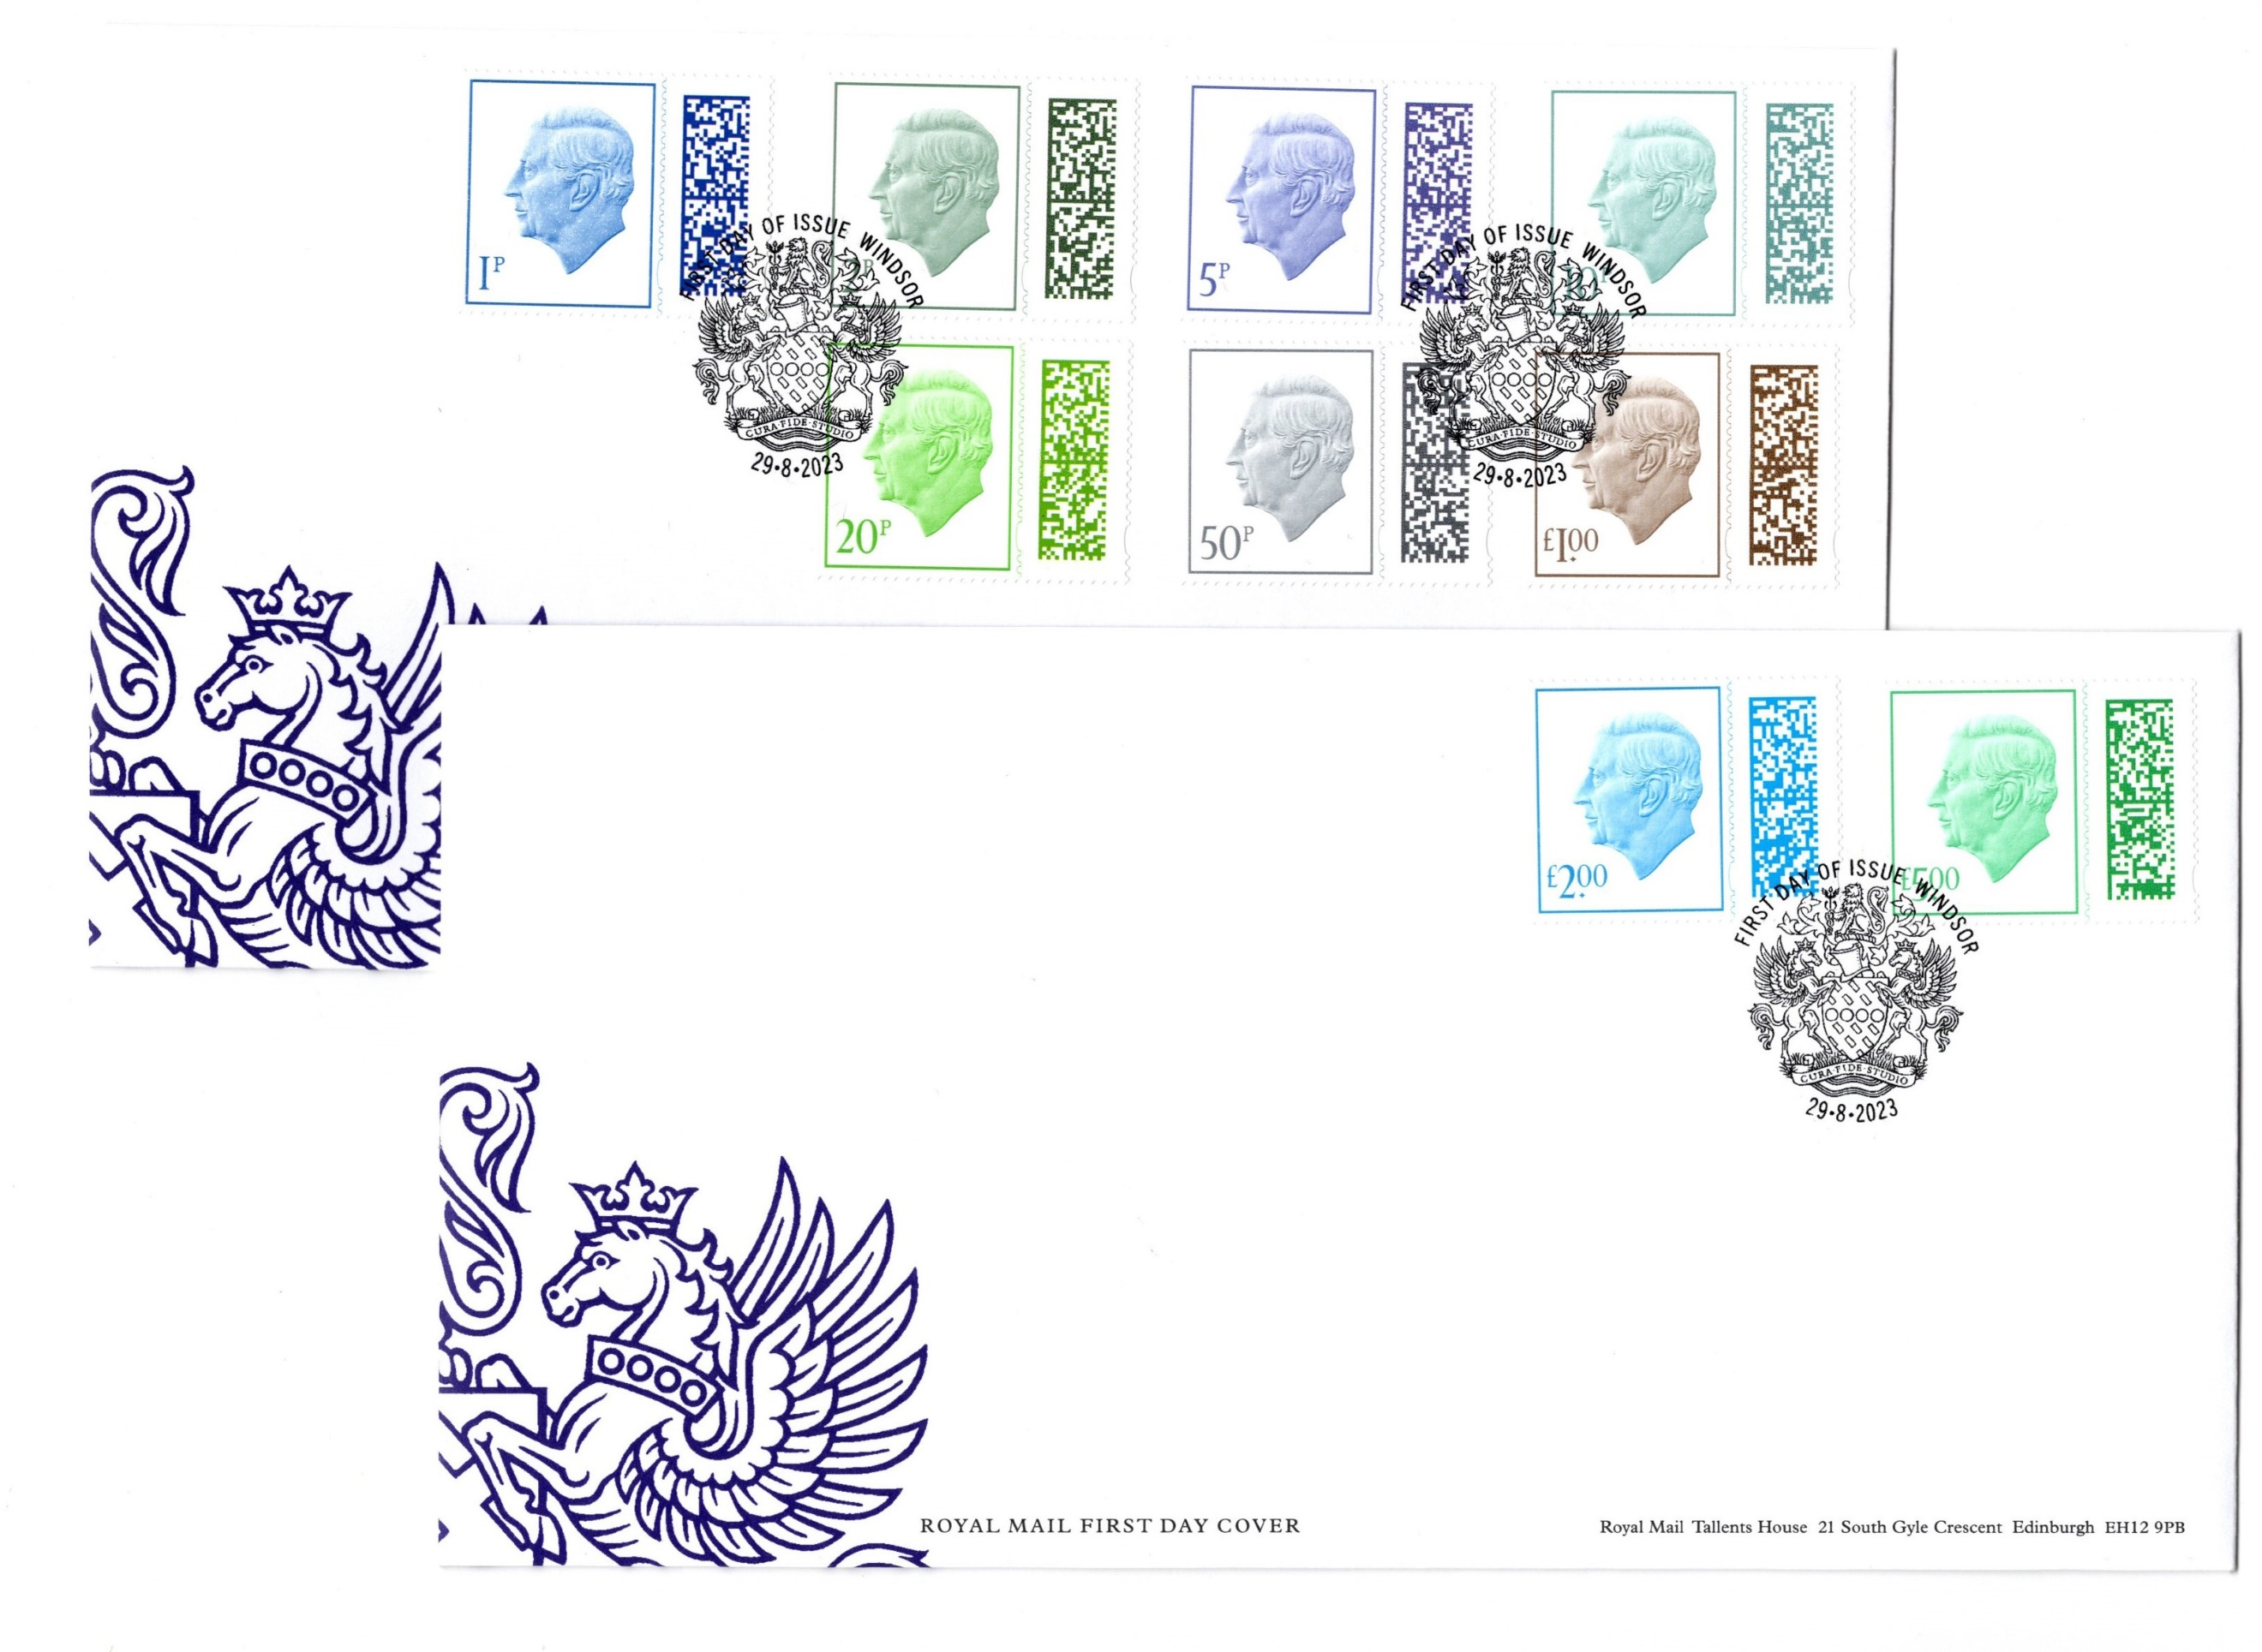
1p to £5 (9 values) ex-Coil Printing
To facilitate the make up of Covers.
Printed without slits in Error.
We have a few examples available
Uncancelled on covers…….. £POR

G.B. PRE-DECIMAL COMMEMORATIVE VARIETIES
All Catalogued by Stanley Gibbons, all U/M. We offer at Specially low prices!
1969 Concorde 4d with ‘Oil Slick’ variety in block of 6, SG 784f (Cat. £30)…… £8.50
Collection of Mint Pre-Decimal & 5 Decimal. Registered Envelopes, Pre-paid Letter & Postcards & 5 Airletters inc. 9d Parliament. A total of 38 items as follows: 4 Decimal Letter/Postcards, 16 Pre-Decimal, 2 Decimal Registered Envelopes & 9 Pre-Decimal
inc. 2 surcharged, 5 Pre-Decimal Airletters Xmas issues & 1 Decimal……£25.00. £20.00

G.B. POSTMARK COLLECTION on covers 1962-67 (e.g. Blackpool Gift Fair, Polphilex London, Scarborough Health Conference, Rotary Conference Blackpool, Royal Highland Show, Dover Packet Service, Brownsea Island Nature Reserve, Pharmaceutical Conference London, IBM World Trade, Shakespeare Anniversary. A.E.P.S. Convention, I.P.A. Congress, Danish Week, Wimbledon Tennis Championship, various Philatelic Exhibitions, etc., etc.
A total of 128 covers on 70 pages………………………………………….. £75.00 £50.00
POST & GO Strips (38) and Presentation Packs (11) from 2013 to 2018 in Royal Mail Album. Including Poppies, Flags, Machin Heads, Heraldic Beasts, Robins, etc. Includes Postal Museum, BPMA, NMRN and other Overprints. Face Value approx. £425, very high catalogue just…………………………………………………………….£425.00 £375.00

G.B. FIRST DAY COVER COLLECTIONS
June 1967 to Christmas 1974, nearly all Royal Mail covers (typed address). A total
of 97 covers including Special Events, Commemoratives, Definitives, Regionals,
High Value Machin £1, Wedgwood Booklet Pane with ½p Left Bnand Good Perfs.
In Green Malvern Double Cover Album………………………………………… £50.00
Jan. 1975 to Christmas 1980 (typed Address) including Machins to £5. Regionals,
Miniature Sheets, Booklet Pane, Special Event covers n Green Malvern Double
Cover Album…………………………………………………………………….. £50.00
Jan. 1981 to Christmas 1986 (typed Address), a total of 81 covers inc. Machin
higher values, Booklet Panes, Framas, Regionals in Green Malvern Double Cover
Album…………………………………………………………………………….. £60.00
Jan. 1987 to Dec. 1991, (typed Address), 80 covers inc. Castle High Values, Defs., Regionals, Booklet Panes, Miniature Sheet in Green Malvern Double Cover Album £55.00
Jan. 1992 to Christmas 1996 (typed Address), 75 Royal Mail covers inc. Castle to £5,
£3 Castle, £10 Britannia, Machins, Regionals, Booklet Panes, Greetings stamps,
French Channel Tunnel Joint Issue with 2 different covers in Green Malvern Double
Cover Album……………………………………………………………………….. £65.00
Jan. 1997 to Christmas 2001 in Royal Mail Double FDC Album (Typed Address),
74 covers inc. Booklet Panes, Miniature Sheets, Regionals & High Values to £5 .. £75.00
Jan. 2002 to Dec. 2002 Christmas set , 23 Royal Mail covers (Typed Address) inc.
Miniature Sheets, Defs. & Booklet Panes in single FDC Album…………………. £40.00
Jan. 2003 to Christmas 2004 (Typed Address) in Royal Mail Double FDC Album,
50 covers inc. Miniature Sheets, Regionals, Defs. to £5, Booklet Panes………… £85.00
Jan. 2005 to Nov. 2006 Scotland Miniature Sheet (Typed Address) in Royal Mail
Double Cover Album, 55 covers inc.Machins, Regionals, Miniature Sheets, Booklet
Panes………………………………………………………………………………. £95.00

LIMITED EDITION PRESTIGE STAMP BOOKLETS
2019 Marvel (DY29)……………………………………………………………….. £89.95
2019 Marvel 80th Anniversary (Limited Edition of 1939) All panes CTO with
special 80th Anniversary postmark…………………………………………………. £74.95
2019 Star Wars (DY31)……………………………………………………………. £45.00
2019 Star Wars Trilogy Slipcase (containing Presentation Packs)………………… £55.00
2019 Star Wars Trilogy Slipcase (containing PSB’s)…………………………….. £75.00
2020 Star Trek (DY36)……………………………………………………………. £60.00
2023 Flying Scotsman (different cover in black & white)………………………… £65.00

GERMAN PRESENTATION PACKS - Sale
1968 Christmas……………………………………………………………..……. £12.00
1969 Ships…………………………………………………………………………. £22.00
1969 Concorde……………………………………………………………………. £45.00
1969 Definitives ½d to 1/9……………………………………………………….. £65.00
ALL
LESS
10%
1969 High Values (SG 787-90)…………………………………………………… £30.00
1969 Anniversaries……………………………………………………………….. £25.00
1969 Cathedrals…………………………………………………………………… £20.00
1969 Investiture…………………………………………………………………… £20.00

AT THE END OF THE DAY THE PRICE DOES MATTER.

WORLDWIDE NEW ARRIVALS
A-Z POT POURRI (All U/M unless stated otherwise)
(Please give a few alternatives if possible as many items are one of a kind) Photocopies available upon request.
ALDERNEY Collection 1983-2018, 671 stamps and 44 Miniature Sheets on 29 Hagner Pages, Face Value over £434…………………………………………………………. £250.00
Collection 1983-2018 Fine Used, 664 stamps and 44 Miniature Sheets on 27 Hagner
Pages, Cat. £407.91………………………………………………………………….. £225.00
Booklet Collection 1994-2014 (SG ASB1-5 Mint plus Used with First Day Cancel,
ASB6-7 Miont, ASB8-9 Mint & Used with FD Cancel, ASB10-15 Mint, ASB21-23
Mint, Cat. £252) in Red Multi=ring album, Face Value over £133………………….. £95.00
1983-94 collection of 22 FDC’s (17 unaddressed) inc. Defs. (e.g. Bids to £1) in
Guernsey P.O. 2-ring FDC album……………………………………………………. £20.00
FDC’s (unaddressed) June 1983 – November 1997, 19 covers inc. 1st Defs., to 18p,
1994 Defs. to £1, Feb. ’95 £1 Seagull & £1.65 Miniature Sheet and £2 Seagull Feb. ’95.
Face Value over £23…………………………………………………………………… £20.00
Presentation Packs 1983 Defs. to 1997 Garrison, a total; of 21 packs, Face Value
£34.63………………………………………………………………………………… £35.00
Official FDC’s (9) unaddressed as follows: 1987 Shipwrecks , 1989 Maps, 1990 Ships,
1991 Les Casquets, 1992 Battle of Hogue, 1989 20p Def., 1991 21p Def., 1992 23p
Def. and 1993 24p &28p Defs………………………………………………………… £10.00
ASCENSION 1971 Defs. to 1992 Airfield SG 135-48, 199-214, 225-40, MS241,
242-67, 269-76 plus Inv. Wmk. set, 277-80, 282A-95B, 297-312, 314-57, 359-79,
381-405, MS406, 407-08, 1986 Ship Defs., 424-31, 433a Strip of 5, 438-41, 442a
Strip of 5, 447-69a, 474-78a, 483-90, 493-96, 504-11, 512a-34, 536-38, 539a-53,
1991 Fish Defs., 569-81 (Cat. £265.85)………………………………………………. £60.00
1987 Royal Navy Uniforms (5v) on Official FDC, SG 433-37……………………….. £1.50
1993-2006 SG 600-03, 608-12, MS613, MS628, 643-55, 662-66, 667a Strip of 4, 671-78, 1996 Bird Defs. 695-707, MS708, 709-12, 713 Strip of 5, MS718, 719-24, MS725, 728-40, MS741, 742-45, MS746, 747-51, 1999 White Tern Sheetlet of 16, 774-84, MS785, 786-93, MS794, 795-98, MS799, MS800, 801-04, MS805, 806-13, MS814, 815-28, MS829, 830a Sheetlet, 834-37, MS838, 839-47, 848-49, MS850, 2002 Defs. 863-70, MS871, 872-3, MS874, 876a, 878-83, MS884, 885-93, MS894, 895-98, MS899, 900-03, MS904, 905-08, MS909, 910-19, MS920, 921-25, MS926, 927-30, MS931, 932-43, MS944, 945-48,
MS949, 2006 Exploration set of 8 in se-tenant pairs, 958-61 (Cat. £638.70)………… £150.00
2007/08 SG 962-MS970, 971-MDS1003, 1004-09 and 1010 – 1023 (Cat. £159)……. £65.00
AUSTRALIA 1988 Joint Issue with the UK/Australia Bicentenary 1788-1988 Presentation Pack contain g both UK and Australia stamps……………………………………….. £5.00
BAHRAIN 1976/80 500Fils, 1Dinar & 2 Dinar Fine Used, SG 243, 244 & 244d
(Cat. £27)…………………………………………………………………………… £7.50
BOOKLETS OF THE WORLD
ALAND 1995 Cargo Ships SG SB3 (Cat. £16)…………………………………….. £6.50
CANADA 1947 SG SB43 (Cat. £55)………………………………………………. £17.50
CYPRUS 1992 Turtles SG SB2 (Cat. £14)………………………………………….. £6.00
ESTONIA 1992 Birds, SG SB2 (Cat. £8.75)…………………………………………. £3.50
FALKLAND ISLANDS 1978 SG SB2 (Cat. £24)…………………………………….. £7.50
FRANCE 1968 Red Cross, SG XSB18 (Cat. £10)……………………………………. £3.50
GREECE 1986 Europa SG SB12 (Cat. £60)…………………………………………. £20.00
1987-88 SG SB14 & 18 (Cat. £16.50)………………………………………………… £7.50
1988 Olympics SG SB16 (Cat. £37)………………………………………………….. £15.00
1990 Europa SG SB22 (Cat. £30)……………………………………………………… £12.00
ITALY 1995 SG SB11 Cat. £19)…………………………………………………….. £7.50
NAMIBIA 1997 Leopard SG SB9 (Cat. £5.50)………………………………………. £2.50
NETHERLANDS 1965 SG SB63 (Cat. £8.50)………………………………………… £3.50
PORTUGAL/AZORES Insects & Butterflies SG SB5&6 (Cat. £27)……………….. £8.50
SOUTH GEORGIA & SOUTH SANDWICH ISLANDS SG SB1 (Cat. £12)……… £6.00
SWEDEN 1967/95 SG SB203, 219, 3452 & 482 (Cat. £47.50)…………………….. £15.00
1994 Europa SG SB473 (Cat. £22)………………………………………………….. £8.00
TRISTAN DA CUNHA 2004 New Island Flag SG SB5 (Cat. £10)………………….. £4.50
VATICAN 2000 SG SB8 (Cat. £12.50)………………………………………………. £3.50
BRITISH ANTARCTIC TERRITORY 1972-91 SG 42-3, 59-60, MS63, 64a, 65,
65a, 66, 66a, 67, 68-74, 75-77, 77b, 78, 78a, 83-86a, 89, 187, 192-207 (Cat. £163)… £50.00
2007 SG 452-460 (Cat. £31.50)……………………………………………………… £17.50
CANADA 1950 Booklet Panes SG 422ba, 423a & 423bba (Cat. £65)……………… £20.00
CAPE OF GOOD HOPE 1853 4d with good margins Fine Used, SG 4a (Cat. £225)…………………………………………………………………………………... £90.00
1858 1d Used with good margins,. SG 5a (Cat. £300)……………………………… £120.00
1855 1d Fine Used with good margins, SG 5b (Cat. £375)………………………… £130.00
1855 4d Fine Used with good margins, SG 6 (Cat. £100)………………………….. £45.00
Do. very good margins, SG 6 (Cat. £100)………………………………………….. £55.00
1858 1/- Used with good margins, SG 8 (Cat. £325)……………………………….. £120.00
Do. Used with heavier cancel……………………………………………………….. £95.00
1859 1/- Used with good margins, SG 8b (Cat. £550)……………………………… £150.00
1864 4d Used with clear margins, SG 19 (Cat. £140)………………………………. £50.00
CHINA 1994 Year Book containing SG 3886-MS3958, Cat. over £110………….. £75.00
1994 Three Gorges Tour Stamp Album containing SG 3896-99, 3906-9, 3914-5, 3936-MS3942 and 3944-MS3948 (Cat. over £34)…………………………………………. £15.00
1994 Mount Huangshan Book containing Pre-Stamped Post Cards (10) and special Commemorative Souvenir Sheet issued by Post Office of Huangshan City (not postally
valid)……………………………………………………………………………………. £25.00
1995 Art of War Presentation Book containing SG 4061-65……………………….. £5.00
1997 Year Book containing SG 4172-MS4252 (ex. MS4204), Cat. over £140…….. £95.00
1997 Having Fish Year By Year: Being Rich Year By Year Presentation Book containing
1993 Bambo SG 3849-50 and MS 3852, 1995 Sweet Osmanthus SG 3972-5 and Miniature Sheet, and 1997 New Year SG 4174-5 in Blocks of 4. Cat. over £40)…………….. £25.00
FALKLAND ISLANDS 1969-92 Collection on hanger pages SG 246-62, 279,
289-92, 296-303, MS306, 307-15, 316-330, 1978-82 Ships A & B to £3, 346, MS367,
368-77a, 383-MS458, 459-70B, 484-95, 497-508, 506w, 510-604, 606-25, 629-55
(Cat. £408)…………………………………………………………………………… £120.00
1977 £2 Silver Jubilee Booklet below Face Value at only…………………………... £1.50
2006/08 SG 1062-65, 1066-71, 1092-95 (Cat. £30.50)…………………………….... £10.00
2007/08 SG 1072-MS1076, MS1077, 1078-81, 10872 Sheetlet of 8 plus 2 labels and
1087-91 (Cat. £106.75)……………………………………………………………… £40.00
2008 Defs. SG 1096-1107 (Cat. £55)……………………………………………..…. £25.00
GERMANY 1941/44 Defs., SG 769, 772, 774, 776, 778-80, 783-88 & 894……… £5.00
GIBRALTAR 1971 Uniforms (4v) in Presentation Pack………………………….. £2.50
GUERNSEY 1940-1998 Christmas Miniature Sheet as follows: 48 Coats of Arms
½d to 2½d various shades used on piece, Regionals 2½d to 4d in multiples (Phos. &
Ord.), 212 stamps inc. 5 Cyl. Blocks of 6, 1st Defs. ½d to 6d Block with varieties, FDC
with 1d & 1/6 wrong & corrected latitude, 2 FDC’s ½d to £1, Brock, Christmas, Liberation
in Blocks of 4 plus 1978 Views & P.O. Anniv. ’79 in Gutter Pairs F/U, P.O. Miniature
Sheet F/U x 2, 1972 Royal w3eddinmg Block of 6 F/U, 1978 Coronation & Royal Visit Black & Gold Proof Miniature Sheets & single, 1993 Rupert Miniature Sheet U/M &
F/U, 7 Registered labels, 42 Airletters inc. Surcharges, a mix of Mint & Used Uniforms,
4 FDC’s to £1, G.B. FFH, Burns, Paris & UNO low values with large Guernsey FD postmarks, selection of Postage Dues 1st issue blocks & pairs to 15p, Pictorial issue
marginal blocks of 4 to £1, 1984 Christmas Miniature Sheet U/M & F/U, 1998 Christmas Miniature Sheet, Uniforms to 9p in Gutter Pairs in large Blue Stock Book…………. £95.00
2000-07 collection of 291 stamps plus 30 Self-Adhesives & 20 Miniature Sheets on
12 Hagner Pages, Face Value £174……………………………………………….… £110.00
Collection 2000-07 Fine Used, 296 stamps plus Self-Adhesives & 19 Miniature Sheets
On 12 Hagner Pages, Face Value over £178…………………………………………. £95.00
Collection 2008-13 on 10 Hagner Pages consisting of 230 stamps plus 16
Self-Adhesives & 20 Miniature Sheets, Face Value over £279……………………… £175.00
2008-13 Fine Used Collection on 10 Hagner Pages consisting of 230 stamps plus Self-Adhesives & 19 Miniature Sheets, Face Value over £278…………………………… £150.00
Booklet Collection 1969-2000 as follows: SB1 to SB70, 73, 74 & 79 inc, SB27, 30,
38, 52, 56 & 59 used with FD cancel plus Private Booklets 1977 Queen’s Jubilee
Charity, London 1980, 1981 Royal Wedding. A total of 87 Booklets in red multi-ring
album. Face Value over £169………………………………………………………… £120.00
1981-89 FDC’s – 66 covers inc. 2 x £2 PNC’s inc. Commemoratives, Definitives
1984-88 to £2, 50% unaddressed. Also includes special event covers in 2-ring
Guernsey P.O. FDC album…………………………………………………………… £35.00
FDC’s in Guernsey P.O. single album May 1970 to Oct. 1979, 49 covers inc. Defs. &
1 Miniature Sheet……………………………………………………………………… £35.00
Do. Feb. 1980 to Nov. 1986, 42 covers inc. Coin Defs. 10p to £2, £5 Coat of Arms,
1984 Views to £1, 1985 Views to £2 and £3 Miniature Sheet………………………. £30.00
Do. 1983 Flowers to £2 to 1997 50 Years Royal Couple & 1996 £3 Flower, 42 covers
inc. 15 Miniature Sheets……………………………………………………………… £35.00
FDC’s Feb. 1987 to Feb. 1993 Rupert Stamp & Miniature Sheet, 40 Official covers (unaddressed) inc. Commemoratives, Miniature Sheets, Defs. & Postage Dues in P.O.
single cover album……………………………………………………………………. £30.00
Presentation Packs in Guernsey P.O. single album – October 1990 to 1993 Rupert &
Flowers Part II 24p to £2 & Views to 26p, 5 Miniature Sheets & 13 Sets inc. Flower
Defs. Part I & II, Face Value over £25………………………………………………. £25.00
Do..Europa 1993 to 1995 Greetings (Feb.), 7 sets & 7 Miniature Sheets/Sheetlets, Face
Value over £20……………………………………………………………………….. £20.00
Do. Europa 1995 to 1996 Christmas & Film Stars (Nov.), 5 Miniature Sheets & 10 sets,
Face Value over £22…………………………………………………………………. £20.00
Do. 1997 Flower Defs. (inc. 25p 1994 & £3 1996), WWF set to 50 Years Royal Couple,
3 Miniature Sheets & 7 sets inc. Defs. & 3 Self-Adhesive, Face Value £17.12…….. £20.00
1969 SB1 to 1989 SB41 Booklets. A total of 39 (ex. SB39 & 40), Face Value £35…. £30.00
HONG KONG – 1973-82 Definitives in Presentation Pack (10c to $50, 14 stamps) Cat. £53.50……………………………………………………………………………….. £20.00
1982 Definitives in Presentation Pack SG 415-30 (Cat. £60)………………………. £20.00
1994 Year of the Dog Miniature Sheets SG MS770 (Cat. £5.50).. £2.50
1997 Part of Hong Kong Skyline Defs. (Low Value) Presentation Pack containing
10c to $5………………………………………………………………………………. £5.00
$1.30 Booklet SG SB16a (Cat. £22)………………………………………………….. £7.50
2000 Year of the Dragon Miniature Sheets (2), SG MS1010, Cat. £29………………. £15.00
IRAN 1935 1T Fine Used, SG 784 (Cat. £70)……………………………………….. £20.00
IRELAND 1922 10/- Seahorse Opt., SG 21 Mounted Mint (Cat. £200)…………….. £90.00
1923 SG 75-79 Mounted Mint, Cat. £82.50…………………………………………. £20.00
1940 1/-, SG 122 Mounted Mint, Cat. £95……………………………………….…. £25.00
1916 3d Opt., SG 126 Mounted Mint (Cat. £22)……………………………………… £5.00
1970/71 FDC’s in “Irish Times” Gold Blocked Folder containing 9 covers as follows:
SG 274-86, 1971 Defs. on 2 covers (15 values to 50p) with 10p Type I (Cat. £10) and
1971 Europa………………………………………………………………………….. £15.00
ISLE OF MAN Collection 2013-2015 consisting of 100 stamps, 12 Miniature Sheets/Sheetlets and 10 Self-Adhesives on 7 Hagner Pages, Face Value over £134…. £95.00
Do. Fine Used, 1009 stamps, 11 Miniature Sheets/Sheetlets and 10 Self-Adhesives,
Face Value over £129…………………………………………………………………. £85.00
FDC’s in I.O.M. P.O. single cover album 1971 & 1973 Regionals then July 1973 to Christmas 1980 inc. Defs. to £1 and 1 Miniature Sheet plus 2 Christmas cards. A total
of 56 covers inc. special events i.e. Airmail Flight to Norway……………………… £45.00
Do. Feb. 1981 to Christmas 1986, 45 covers inc. Miniature Sheets & Defs. Birds to £1
and £5 Queen plus 6 Christmas cards (all typed addresses)…………………………. £35.00
do. Jan. 1987 to Christmas 1991, 41 covers inc. Miniature Sheets & Defs. to £1 and
£2 Queen plus 5 Christmas cards (all typed addresses)………………………………. £25.00
Do. Jan. 1992 to Olympics 1994, 29 covers inc. 5 Miniature Sheets, £2 Flag &
£5 Portraits Defs. plus 3 Christmas cards…………………………………………….. £35.00
Do. Feb. 1995 to Christmas 1997, 36 covers inc. 9 Miniature Sheets plus 4 Christmas
cards (all typed addresses)……………………………………………………………… £30.00
Presentation Pack collection in 10 albums 1973 to 1997 comprising of 148 Commem-
oratives, 29 Miniature Sheets/Sheetlets, 80 individual Def. stamps, 2 sets Postage Dues
to £5, 9 Booklets stamps and 1 Post card, Face Value over £182…………………. £125.00
2010 Official Isle of Man Cover with Congratulations Miniature Sheet of HRH Prince William of Wales to Miss Catherine Middleton signed by the Designer Emma Cooke £10.00
JERSEY Collection 2011 Queen’s 85th to 2014 Red Arrows, 253 stamps & 27 Miniature Sheets, Face Value over £246 on 16 Hagner pages…………………………………. £175.00
Do. Fine Used, 247 stamps & 25 Miniature Sheets, Face Value over £240………… £150.00
Booklet Collection in Blue Multi-ring album 1975-2017 as follows: SB4a, 10a, 11a,
21-23, 25-26, 28, SG 142 & 3 Sachet Booklets, 36, 44, 51, 62, 64, 74-75, & 78. Face
Value over £84……………………………………………………………………..… £65.00
1969-1987 FDC’s unaddressed (3 Typed Address), 48 covers inc. 1983 £5 Def. &
1982 Coat of Arms to £1 in New Pioneer Cover Album…………………………… £30.00
FDC’s in single Jersey P.O. cover album Feb. ’85 to Nov. ’86, 17 covers inc. 1 Miniature Sheet, Defs. inc. £1 Queen……………………………………………………………. £20.00
Do. Jan. ’87 to Christmas ’89, 36 covers inc. Defs. to £1 & £2 Queen……………… £25.00
Do. Jan. ’92 to Oct. ’95, 38 covers plus 1 Miniature Sheet used, NVI 3 x Blocks of 4
se-tenant (Jan. ’93), 6 Miniature Sheets, Coat of Arms £4, £1 Queen……………….. £40.00
do. Feb. ’96 to Nov. ’97, 21 covers inc. 3 Miniature Sheets, £5 Queen’s 70th, Birds to £2, NVI set of 4…………………………………………………………………………… £20.00
Presentation Packs 1974 Flowers to 1981 Europa plus low value Defs. A total of 40
Packs in 2 Jersey P.O. albums, Face Value over £24 inc. 2 Miniature Sheets………… £30.00
Do. 1996 Horses to 1997 Golden Wedding Miniature Sheet, 11 sets inc. NVI Self-
Adhesives (4v)n & Birds 1p to £2 (8v) & 3 Miniature Sheets, Face Value over £27… £20.00
KIRIBATI 1976-1982 SG 60-67, 68a, 71-78, MS79, 80-84, 86-99b, 100-03, MS104,
105-11, 112-15 Sheetlets of 10, MS116, 117-20, 121-35, 136-48, 1981 Royal Wedding Sheetlets of 7 & S/Sheet, 158-61, MS162, 1982 Bird Definitives, 179-85, O11-O25,
O26-O35………………………………………………………………………………. £25.00
MAURITIUS 1975 10Rs. Fish, SG 491 Used (Cat. £9.00)…………………………. £2.50
MONTSERRAT 1975-81 Miniature Sheets and Sheetlets as follows: SG MS362, MS408, MS416, MS421, 422-5 Sheetlet of 10, MS426, MS435, MS440, MS445, MS447, 448-51 Sheetlet of 10, MS452, 460-63 Sheetlet of 4 plus 2 labels, MS466, 468-74 Sheetlet of 3
plus label, MS475, 486-89 Sheetlet of 10 plus 486 Upr. Wmk., 1981 Royal Wedding
510b-14b Sheetlets, MS516, MS527 and Booklets SB1 & SB5 (Cat. £97.60)………. £25.00
1976-1981 SG 356-61, 409-11, 412-15, 417-20, 427-34, 436-44, 446, 453-55, 456-59,
456w-59w, 467, 476-81, 482-85, 490-505, 506-09, 519-26, 528-41 plus Used Officials
as follows O16, O17-26, O27-41 and O42-52……………………………………….. £25.00
1989 $10 Shell Official, SG O90, Fine Used…………………………………………. £2.25
1994 World Cup Football set & S/S, SG 936-MS9400 (Cat. £12.05)…………………. £6.00
1995 5th International Amateur Athletic Exhibition S/S, SG MS966 (Cat. £4.50)…….. £2.50
1996 James Dean Set & S/S, SG 999-MS1008 (Cat. £7.75)…………………………… £4.00
1996 Jerry Garcia SG 1025-27 in Sheetlet of 9 (Cat. £9)……………………………… £4.00
1997 Rock Legends SG 1055-58 (Cat. £7).……………………………………………. £3.50
1997 Frama Exhibition Sheetlet of 8, SG 1059 (Cat. £8)………………………………. £4.00
1997 Pacific ’97 International Stamp Exhibition Opt. on 1996 James Dean Sheetlet….. £2.50
1998 Total Eclipse of the Sunset & S/S, SG 1104-MS1108 (Cat. £16)………………. £8.00
1998 Rock Music Legends SG 1086-MS1103 (Cat. £21.70)…………………………. £10.00
1999 Endangered Species/WWF Sheetlet of 16, SG 1148-51 (Cat. £13.60)………….. £7.50
1999 Jerry Gacia SG 1117-28 in 3 Sheetlets of 9 (Cat. £24.30)………………………. £12.00
2001 Queen Elizabeth II’s 75th Birthday set & S/S, SG 1185-MS1189 (Cat. £16)….. £8.00
2001 Famous Stamp Personalities SG 1180-83 (Cat. £8.75)………………………….. £4.50
2003 Mushrooms of the World, SG MS1240-41 (Cat. £13.50)……………………….. £7.00
2004 Fish S/S, SG MS1259-60 (Cat. £12.50)………………………………………….. £6.00
2004 Bicentenary of Steam Locomotives, SG MS1261-63 (Cat. £19)………………… £9.50
2005 10th Anniversary of the Eruption of Soufriere Hills Volcano S/S, SG MS1284… £10.00
2006 World Cup Football S/S, SG MS1331 (Cat. £8.50)………………………………. £4.00
2007 World Cup Cricket set & S/S, SG 1349-MS1351 (Cat. £24)…………………… £12.00
2007 Flower Defs. to $20, SG 1352-67 (Cat. £48.95)……………………………….. £25.00
2009 80th Birth Anniversary of Martin Luther King S/S, SG MS1426-27 (Cat. £18)… £9.00
NAMIBIA 1997 (No. 6) Flora & Fauna Booklet of 18 stamps……………………….. £5.00
NETHERLAND ANTILLES 1952 SG 338 & 340, Cat. £38………………………. £7.50
1952 SG 340, Cat. £20………………………………………………………………… £4.50
NEVIS 1980-82 SG 37-49, 50 Sheetlet of 10, 51-54, 54a pair, 58A-71A, 1981 Royal
Wedding Sheetlets of 7, 55-57 Sheetlets of 8, 81-84, O1-10 plus O2c (No Wmk.),
O11-22………………………………………………………………………………….. £10.00
NEW ZEALAND 1960 Health Miniature Sheets(Birds) set of 2,SG MS804b, Cat. £18 £7.50
1992 Seals, SG 1664-69…………………………………………………………….. £4.00
OMNIBUS – 1974 CHURCHILL Sets & Miniature Sheets Aitutaki to Turks & Caicos
including both sets from Brunei and Barbuda + 2 Miniature Sheets, G.B., I.O.M., Jersey,
St. Vincent & Grenadines in Gutter Pairs. A total of 29 sets and 24 Miniature Sheets inc. Scarce Maldives Miniature Sheet, normal retail over £60………………………….. £20.00
1977 SILVER JUBILEE issues Aitutaki to Tuvalu in 2-ring printed Album. Also
includes Foreign countries Comoro, Tchad, Guinee Republic, Liberia,Togo and Congo.
G.B. Airletter, Booklets from Grenada, Gren. Grenadines, St. Vincent & Turks x 2 stapled Left & Right. A total of 67 countries with a total of 282 stamps Inc. Imperfs, 35 Miniature Sheets inc. Imperf, 5 Booklets and 1 Airletter. Normal Retail over £230 ……………. £50.00
1977 SILVER JUBILEE Commonwealth collection of 69 Sets. Inc.Imperfs & 24
Miniature Sheet in small Jubilee album plus hanger cards………………………….. £35.00
1981 ROYAL WEDDING Collection in S.G. Multi-Coloured ring album with printed
pages in slipcase. Containing Tanzania Set & Miniature Sheet Optd. Tonga Self-Adhesives set of 4 plus ‘Specimen’ Opts., Cyclone Relief Opt. plus ‘Specimen’ Opt., Tristan Da
Cunha, Turks & Caicos Set & Miniature Sheet, Set of 3 Sheetlets (Change of Perf.),
Tuvalu set of 6 with ‘Specimen’ Opt., Set of 3 Sheetlets, 2 Booklet Panes, $1.50 Miniature Shet plus ‘Specimen’ Opt., Tonga Relief Sheetlet, , Double Opt. on 20c & 45c stamps, Uganda Set of 3 Perf. 12 x 12½, Set of 3 Change of Colours, and Perf. 14 Miniature
Sheet 250/-, Perf. 14 Optd. Set of 3 Small Opts., Set of 3 Large Opts. plus Miniature
Sheet, Set of 3 Sheetlets, Vanuatu Set of 3, Seychelles ‘Specimen’ Opt. set of 6,
Zil Eloigne Sesel Set of 3 Sheetlets, plus Miniature Sheet and Optd. ‘Specimen’
Miniature Sheet, 2 Booklet Panes and set of 3 Optd. Provisional Surcharge 3 Sheetlets.
Must be worth……………………………………………………………………….. £40.00
1981 ROYAL WEDDING Booklets from Kiribati, Nevis, St. Kitts, St. Vincent,
Grenadines of St. Vincent, ZES/Seychelles, a total of 6 booklets………………….. £5.00
PITCAIRN ISLANDS 1977 Defs. to 1992 Accession SG 174-84, 181w, 185-87,
MS189, 190-93 plus Inv. Wmk. set of 4, 194-203, MS205, 206-15, 213w, 214w, 216-62, 257w, 264-71, 269w, 271w, 273-313, 315-334, 348-88, 395-413 (Cat. £172)………. £50.00
1990 $4.40 Booklet, SG SB2 (Cat. £11)……………………………………………… £6.00
1993-2006 SG 430-53, 458-61, 483-98, MS499, 500-09, MS510, MS511, 512-33,
MS534, 553-58, MS559, 560a Strip of 5, S576, 577-80, MS581, MS582, 583a Strip
of 4, 587-94, MS595, 596-603, MS604, 605-12, 618-21, MS622, 623-26, MS627,
628a Strip of 5, 632-35, MS636, 637-45, MS646, 647a Strip of 5, 651-54, MS655,
656-67, MS668, 669-72, MS673, 674-78, MS679, 680-85, MS686, MS687, 688, 689-92, MS693, 694-98, MS699, 700-09, MS710, 711-14, MS715, 716a Strip of 5, MS720,
721-22, MS723 (Cat. £638.75)………………………………………………………. £175.00
2007-2018 as follows: 724-54 inc. 3 Miniature Sheets, 759-MS767, MS774-MS989
(i.e. 48 sets inc. 2011 Royal Wedding Pres. Pack, 1 Sheetlet [824-25], 25 Miniature
Sheets and 977-84 Sheetlet), 991-94, MS995, 996-97, 998-99, MS1000, 1001-04 and
1011-12 (Cat. £988) on 12 Hagner Pages………………………………………….. £250.00
2007-2017 Christmas Greetings Cards (11 cards) with 60c to $5 stamps all VFU (Cat. £40.25)………………………………………………………………………………. £15.00
ROSS DEPENDENCY 2008 British Antarctic expedition (5v) on Official FDC,
SG 110-14 (Cat. £15.50 as used)………………………………………………………. £7.50
RUSSIA 1977 Space Set SG 4690-5 on 5 FDC’s plus MS4696 U/M (Cat. £19.20)
In a Commemorative Booklet with a biography of the artist and astronaut Alexi
Leonor issued by “Franklin Mint”………………………………………………….. £10.00
ST. HELENA 1976 Defs. to 1992 Queen’s Accession SG 319A-31B(3 values), 332-34,
338a Sheetlet, 341-64, MS365, 366-76, 378-400 plus 399a Perf. 13½ x 14, 401-MS458,
459, 611. A total of 67 sets and 2 Miniature Sheets & 1 Sheetlet plus 476w Inv. Wmk.
(Cat. £229.45)………………………………………………………………………… £75.00
1994 Christmas to 2006 Christmas SG 671-75, 681-843, 705-MS720, 721-MS725,
726-MS740, 741-MS745, 746-MS7752, 753-MS761, 783-MS785, 786-MS794, 795-
MS799, 800a Sheetlet – MS814, 8156a Strip – MS820, 821-MS827, 828-MS842,
843-50, 852-MS856, 861-MS871, 872-MS876, 878a Sheetlet – MS891, 905-MS911,
912-MS925, 926-MS945, 946a Sheetlet – MS978, 979- MS983, 984-MS988, 989a
Sheetlet -1010 (Cat. £566)…………………………………………………………… £150.00
2007-08 SG 1019-MS1022, 1028-MS1052, MS1053, 1058-69, 1072-MS1083
(Cat. £169)……………………………………………………………………………. £50.00
ST. KITTS 1980-82 SG 1-9, 29A-41A, 29B-41B, 42-46, 48 Sheetlet of 10, 49-52,
53A-70A, 53B-70B, 71-74, 1981 Royal Wedding Sheetlets of 7, S/Sheet, 88-91, 92-93, MS94, O1A-10A, O2B-10B, O11-22 (Cat. £91.45)…………………………………. £25.00
ST. VINCENT GRENADINES FDC’S (unaddressed) SG 3-17 Opts.(2 covers),
18-23, 35A-52A 1c to $5 (3 covers)………………………………………………….. £5.00
1974-1982 SG 3-23, 35A-52CA, 104-09, 110-29 plus 5c, 6c, 8c, 10c, 15c, 20c, 25c
and $2 with Different Imprint Dates, 135-38, 139-43, MS144, 1978 Coronation Sheetlets
of 10, S/Sheet, 156-59, 160-62 Sheetlets of 10, 163-66 London 1980 Sheetlets of 10 & S/Sheet, 171-78, 179-83, MS184, Bequia Island Sheetlets of 10 SG 189-94, 1981 Royal Wedding Sheetlets of 7 & S/Sheet, 204-07 1982 Defs. & 225-28……………….. £35.00
1975-82 SG 415-20, 1975 Xmas Sheetlets, 479-84, 541-49, MS550, 551-55. 556-59
Sheetlets of 10, MS560, 561-78, Rowland Hill Sheetlets of 10, MS581, 1979 Def. 602,
603-05 Sheetlets of 10, Independence Opts. 1c to $10 set of 29 inc. various imprint dates, 1979 Xmas Set & S/Sheet, 628-32, MS633, 634-36 Sheetlets of 10, MS637, 638a, 640-47, 648-50 Sheetlet of 10, 651-54, MS655, 656-59, 660a-66a, 1981 Royal Wedding Sheetlets
of 7 & S/Sheet, 677a, 679-80 Sheetlet of 5, 1981 Xmas inc. Inv. Wmks., 686-89….. £30.00
SOUTH GEORIA & SOUTH SANDWICH ISLANDS Collection 1993 SG 227-30
to 2006 Communications, a total of 29 Sets and 14 Miniature Sheets (Cat. £579.90),
B.A.T. 1993-2004, a total of 31 Sets inc. 1993 & 2003 Definitives and 14 Miniature Sheets/Sheetlets (Cat. £705.50), Falkland Islands 1993 Pets to 2006 Birds SG 1057-59,
a total of 26 Miniature Sheets/Sheetlets and 67 Sets inc. 1994 & 2003 Defs. (Cat.
£1083.50). Total Cat. £2368, great value at only……………………………………. £850.00
2007 SG 435-8, MS439, 440-44, 445-52 (Cat. £60.50)…………………………….. £28.50
2007-08 SG 431& 433a, 453-6 plus Sheetlet MS457 (Cat. £56)…………………… £20.00
SYRIA 1936 Damascus Overtprints SG 300-08 (Cat. £41) with some foxing…….. £12.00
THAILAND 1959 Games, SG 396-99 (Cat. £18) with some foxing………………. £6.00
TONGA 1980 Surcharges 5p on 25s and 5p on T$2, SG 773a & b, Cat. £32………. £15.00
2015 Chinese New Year – Year of the Sheep S/S, SG MS1762, Cat. £25………….. £12.50
2015 Chinese New Year – Year of the Monkey S/S, SG MS1782, Cat. £25………… £12.50
TRISTAN DA CUNHA 1976/91 Miniature Sheets (21) Cat. £31…………………. £15.00
1977 Crests to 1992 Queen’s Accession SG 215-18, MS219, 1977 Bird Defs., 232-33,
234-7, MS238, 239-41, 239b Sheetlet, 242-53, MS254, 255-62, MS263, 264-66, MS267, 268-75, MS276, 277-87a, 296-302, MS303, 304-6, MS307, 308-15a, 319-23, MS334,
335-60 plus 359w & 360w, 361-63, MS364, 365-80, MS381, 382-85, 386-88, MS389,
390-93, MS394, 395-401 plus 399w & 400w, 402-10 plus 406w & 409w, 411-25,
430-60, 1988 Painting Defs. 473-512, 514-30 (Cat. £221)………………………… £50.00
1993-2006 SG 542-55, 553-68, 576-79, 586-MS610, 611-MS619, 620-MS630, 631-
MS636, MS637, 655-MS661, 662-MS682, 683-MS687, 688a-MS700, 701-MS707,
708a Sheetlet -0 MS724, 725-MS739, 740-MS744, 749-MS751, 752a Sheetlet, 787a-91a, 800-03, 828a, 833-44, MS849, 850a, 855a, 860-MS864, 866a (Cat. £559.560)……. £150.00
2007 SG MS871, 872-77, 878-81 & MS882 (Cat. £50.50)…………………………. £20.00
2009 SG MS883, MS888, 895-906 (Cat. £77)……………………………………… £35.00
TUVALU 1978-81 SG 89-92 Sheetlets of 10, MS93, 123a Sheetlet of 3, MS134,
MS147, 148 Sheetlet of 10, 162-67 Ships Sheetlets of 6, 1981 Royal Wedding Sheetlets
of 7, MS174 plus Royal Wedding Bklt., 177-78 Sheetlet of 10, MS179…………….. £20.00
‘WALLACE’ STOCK – MADE UP PACKETS – ALL NOW LESS 10%
Over 55 years ago the ‘Wallace’ stock was locked away – comprising a massive Worldwide range of Mint/Used – much untouched since the end of World War II! All off paper, all different, very interesting selection. Approx. 10 of each available – these packets were made up over 75 years ago! In those days the stamps were common, many not so nowadays!
Botanical & Agriculture, packet of 50 stamps (3/6)…………………………………. £7.50
North & Central America, packet of 50 stamps (2/6)……………………………….. £5.00
Officials, packet of 25 stamps………………………………………………………….. £3.50
Scenery, packet of 25 stamps (2/-)……… £5.00, do. Packet of 50 stamps (5/-)……… £9.50
Italy – Prep1950 packet of 125 stamps to include Commemoratives, Express, Parcel Post, Postage Dues plus a few Colonies, etc. in original packet made up over 60 years ago. Very high Cat. (25 only available)………………………………………………………….. £10.00
Do. Packet of 75 different Italy (mainly Definitives) £5.00, Do. 150 different……… £9.50
ZIL ELOIGNE SESEL (Seychelles) 1980-82 SG 1-16, 17-19 Sheetlets of 10, 20-22 Sheetlet of 10, 1981 Royal Wedding Sheetlets of 7 and MS29, 32-37 (Cat. £31.50)…. £10.00

CLEARANCE SALE OF OVER 5,000 POSTCARDS
NEW LOWER PRICES!
Amassed over the years from all over the place – collections/accumulations/job lots/charities, etc. Many thousands to clear with little duplication if any and no lots the same.
WORLD POSTCARDS (USED) – No G.B. – mainly holiday views from all over the world Per 100……………………………… £9.50, Per 500……………………………….. £40.00
WORLD POSTCARDS (UNUSED) – Could be anything, Views, Art, Advertising, etc.
Per 100………………………………. £9.50, Per 500………………………………. £40.00
G.B. ONLY (UNUSED) – a right mixture – Views, Advertising, Royalty, Transport, Art, etc. Per 100………………………….. £9.50, Per 500……………………………….. £40.00
Larger quantities available as above pro-rata.

NEW LOWER PRICES ON “ACCESSORIES”
2ND HAND ALBUMS – VIRTUALLY AS NEW (All UK Postpaid):
Please note that in most cases there are only one of each of these available so early ordering is advisable to avoid disappointment. Order any 2 items or more and deduct 10%.
SB1 – “W.H.Smith” Dark Green Stockbook, 16 pages (32 sides) with Glassine Strips
& Interleaving………………………………………………………………………… £12.50
SB2 – Deep Claret De-Luxe Stockbook, 32 pages (64 sides|) with Clear Plastic Strips
& Interleaving………………………………………………………………………… £17.50
SB3 – Dark Blue Crest Embossed Great Britain 32 pages (64 sides) Stockbook with
Glassine Strips & Interleaving………………………………………………………… £17.50
SB4 – Dark Green Stockbook, 32 pages (64 sides) with Plastic Strips & Glassine
Interleaving…………………………………………………………………………… £17.50
SB5 – “KEK” De-Luxe Stockbook in Dark Brown, 16 pages (32 sides) with Plastic
Strips & Interleaving…………………………………………………………………. £12.50
SB6-9 – Deep Claret De-Luxe Stockbook, 32 pages (64 sides) with Plastic Strips & Interleaving, each……………………………………………………………………… £17.50
SB10 – “LIGHTHOUSE” Navy Blue De-Luxe 23 page (46 sides) Stockbook with
Black Pages, Plastic Strips & Interleaving (slight crease in front cover)……………. £14.50
SB11 – WESSEX” Knight Deep Blue De-Luxe 32 page (64 sides) Stockbook with
Black Pages, Plastic Strips & Glassine Interleaving…………………………………… £17.50
SB12 – “Prophila” Collection Deep Claret 30 pages (60 sides) Stockbook with Glassine Strips & Interleaving…………………………………………………………………. £16.50
SB13 – “COMPASS” Dark Green Stockbook, 24 pages (48 sides) with Glassine
Interleaving……………………………………………………………………………. £15.00
SB14 - 30 Leaf quality (60 sides) Stock Book in Dark Blue with Glassine Interleaving. £14.50
SB15 – “WESSEX” Paragon Blue Stockbook, 32 pages (64 sides) with Glassine Strips
& Interleaving…………………………………………………………………………. £17.50
BLACK SINGLE LINE CARDS (ex. Presentation Packs) x 100…………….….. £12.50
SINGLE FIRST DAY COVER ALBUMS – Box of 9 (3 x Merlin, 4 x Quantock
and 2 x FDC Albums to clear………………………………………………………… £45.00
BENHAM ‘The PNC Collection’ Album (Velour Binder) with pages………………. £10.00
Do. Faux Leather effect……………………………………………………………….. £10.00
Do. Plastic effect………………………………………………………………………. £10.00
STANLEY GIBBONS – ISLE OF MAN STAMP ALBUMS in 5 volumes (1941-2018)
with 2 slip cases, Hawid style mounts have been affixed to most pages, original cost
must have been over £200 …………………………………………………………… £70.00
STANLEY GIBBONS – General Purpose Standard Size Spring Back Album in Red £10.00
Do. as above but Green……………………………………………………………….. £10.00
Senator Spring Back Binder in Red…………………………………………………… £10.00
Do. as above in Dark Green……………………………………………………………. £10.00
New Age Spring Back Binders in Red, condition good for the age of them………….. £10.00
STANLEY GIBBONS – Windsor Album “Volume 4” Pages for Machin Definitives
1991-1999 in Green Binder, some black Hawid mounts included………………….. £25.00

Breaking up First Day Cover Collection:
Now with 25% Discount
1967 Machin 4d, 1- and 1/9 on Coventry Cathedral cover with special Coventry 5th Anniversary cancel, typed address (Cat. £17.50)…………………………………….. £5.00
2/- Booklet Se-tenant pane of 4d x 2 plus labels on Stuart or Connoisseur cover addressed
in Pen/label, Cat. £20……………………………………………………………………. £6.50
2/- Booklet on Philart cover with Pane of 4d x 4 Vermilion and 4d x 2 plus labels,
Cat. £90……………………………………………………………………………….. £35.00
1969 Stamps for Cooks Pane of 15 x 4d (Method) on addressed cover……………… £3.00
Do. with MMB cancel………………………………………………………………… £5.00
Do. Pane of 15 x 4d (Stuffed Cucumber) on plain Registered cover…………………. £3.00
Do. Pane of 15 x 5d on addressed cover………………………………………………. £3.00
Do. with MMB cancel…………………………………………………………………. £5.00
25%
DISCOUNT
Do. Se-tenant Pane of 15 (Baked Stuffed Haddock) on plain cover………………….. £5.00
Do. Se-tenant strip of 5 from Se-tenant Pane on cover……………………………….. £3.00
Do. on Stuart cover with MMB cancel (Cat. £30)……………………………………. £10.00
1971 Pane of 2½p plus label…………………………………………………………… £5.00
Do. Pane of 3p x 5 plus label………………………………………………………… £5.00
Do. Pane of 3p x 4 plus 2½p x 2……………………………………………………… £5.00
1971 Pane of ½p x 5 plus label on Advertisers Booklet Pane cacheted cover……….. £5.00
Do. Pane of 2½p x 5 plus label (2 different labels available), each……………………. £5.00
1973 50p AOP on Stuart unaddressed cover (Cat. £95)……………………………. £37.50
1973 50p Booklet Pair of Stuart covers bearing 3p x 5 plus label and 3½p x 5 plus label
on typed address covers (Cat. £90)………………………………………………….. £25.00
1973 Machins 4½p, 5½p and 8p in Blocks of 4 on 3 Post Office covers, addressed… £5.00
1974 3½p Centre Band on Cotswold cover with Windsor postmark, some tropical
Staining……………………………………………………………………………….. £5.00
1974 4½p AOP on Stuart cover addressed…………………………………………… £2.00
Do. with Windsor postmark (Cat. £30)………………………………………………. £10.00
Do. on Colorano ‘Silk’ Cachet cover with Chief Office, London EC1 cancel………. £12.50
Do. on Philart unaddressed cover with Cambridge CDS (Cat. £35)…………………. £17.50
1977 50p Booklet on 2 covers with 6½p Left and Right…………………………….. £3.00
Do. with Windsor Pictorial handstamp………………………………………………. £12.50
1977 50p Booklet on 2 covers with 7p Left and Right………………………………. £3.00
Do. plain covers with pair of panes cancelled by Windsor Pictorial postmark……… £5.00
1977 50p Ochre on Post Office addressed cover in pencil cancelled by Windsor postmark
and having the £1 Machin (large) with the same postmark…………………………… £5.00
1977 7p CB on cover with 7p LB and 7p RB with Windsor Pictorial cancel………… £5.00
1980 ½p PCP in Block of 4 on Stuart cover with additional 8p Machin Windsor cancel £1.50
Do. as above but on Connoisseur cover with 10p Machin…………………………….. £1.50
Do. strip of 3 x ½p and 10½p Machin on Stuart cover with Windsor cancel………….. £1.50
Do. P.O. cover with ½p and 11½p Machins with Windsor cancel…………………….. £1.50
1980 Christmas Booklet Complete Pane on Philart cover with Windsor cancel………. £5.00
Do. 10p/12p Se-tenant Pair ex. Booklet (various cachets)…………………………….. £0.50
Do. as above but Blocks of 4…………………………………………………………… £0.75
1980 Multi-Value Coil Strip on cover (various cachets and cancels)…………………. £1.00
Do. with Windsor or Chief Office, London EC1 cancel………………………………. £5.00
1980 10p Booklet Pane on cover with Windsor cancel……………………………….. £2.00
1980 11p PCP Machin on cover with Windsor cancel…………………………………. £3.00
1980 75p Machin on cover…………………………………………………………….. £1.00
1986 plain cover with 2p & 75p ACP cancelled by Windsor postmark plus Wales & Northern Ireland 17p cancelled by Windsor postmark………………………………… £5.00
1986 12p Christmas on Cotswold cover with The Glastonbury Thorn cancel……….. £3.50
1987 large plain cover with 1p/13p, 13p/18p, 1p/13p, 5p and 13p all ex. Booklets cancelled by Windsor cancel……………………………………………………………………… £5.00
2002 68p Regionals (all 4) on RM cover with St. George, London cancel……………. £4.00

CORRECTION AND AMENDMENTS TO RUSHEXPRESS NO.79
Page Description Old New
Price Price
4 DY21 2017 50th Anniversary of the Machin PSB £35.00 £45.00
20 SG 573Wi U/M £56.00 £65.00
50 Set of 5 NVI (SG 2357a, 2357b, 2358, 2358a & 2359) £ 9.50 £10.50
Please Note: Due to the Postal Rate increase of October 2nd, 2023 please refer to RushTelegraph No. 73 for some additional price changes which supersede RushExpress
No. 79 pages.

CORRECTION AND AMENDMENTS TO RUSHTELEGRAPH NO.73
Page Description Old New
Price Price
8 1976 Caxton British Printing Traffic Light Gutter Pairs
‘To Tuck Away’, 10 pairs £1.00 £10.00

